Christina Puccinelli September 28, 2017
Banking For Friends

State of the Economy
- The economy in the US is growing steadily: 3% last quarter, and 1.2% first quarter
  - We’ve been at 1-2% growth rate since the great recession of ’08 – ‘09
  - This is also with the government keeping interest rates really low (1.25%), giving companies incentives to invest
  - Low interest rates also cause investors to invest in stocks, because investing in debt pays very little interest
  - If everyone is investing in stocks, the stock market goes up, and people feel richer, and that stimulates the economy
  - We would like about 3-4% growth, but not more – because this leads to inflation
    - So the government is slowly raising interest rates, beginning last year
- Unemployment right now is very low, at 4.3%
  - When unemployment rates get too low, fewer people are looking for jobs, and then companies need to pay higher salaries, and then their earnings go down
- Stocks are at an all-time high right now, because when Trump was elected, he preached stimulating the economy by lowering taxes, deregulating and investing in infrastructure
  - None of this has happened, but the stocks have been high since November
  - People get excited about companies making more money, so they buy stocks in anticipation
    - Regulation is expensive
- Trump tax reform
  - Trump wants to cut corporate taxes, so that companies have more funds to invest in their own activities
- A war with North Korea would be bad for the markets

What is investment banking?
- Investment banking is a business that provides services to companies.
- These services include raising capital - both debt and equity – and advising in major transactions such as mergers and acquisitions, bankruptcies, and restructurings.
- An investment bank will typically be divided into industry groups such as healthcare and retail, and product groups such as mergers and acquisitions and capital markets.
- At the senior levels, investment bankers are more focused on the clients and building relationships that can generate deal flow.
- At the junior and middle levels, the bankers are usually more focused on executing the given service at the highest level of quality possible to ensure repeat business

- Investment banks sell the company’s securities (debt and equity) to investors in order to raise the cash.
  - These securities can come in the form of stocks, bonds, or loans
  - Debt or Equity
    - When choosing to raise capital, a company might have the option of equity or debt
    - Debt, representing a repayment obligation, is usually less expensive than offering equity
    - However debt requires the company to pay regular interest payments to investors (equity does not) but equity requires the company to sell a portion of itself to the general public (debt does not)
      - P/E Ratio
      - Stock price / earnings per share
        - Indicates how cheap or expensive a stock is
  - Once issued, these securities trade in the global financial markets
- If, for example, a company wants to buy another firm, then the investment bank will help finalize the purchase price, structure the deal, and generally ensure a smooth transaction

DCF Analysis
- Method for estimating the intrinsic value of a company
  - Based on the company’s own future expected cash flows and the risk of those cash flows (as opposed to comparable-based analyses, which are based on multiples derived from other companies)
  - Adjusted by the time value of money and the inherent risk of the cash flows
- The value of a company is equal to the present value of its future cash flows discounted based on the risk of those cash flows

- A DCF values a company based on the Present Value of its unlevered free Cash Flows and the Present Value of its Terminal Value, both discounted at the Weighted Average Cost of Capital (or WACC)
  - Unlevered free cash flows = cash flows generated by the company before financing costs, such as the payment of interest to debt holders or the payment of dividends to equity holders
  - You use unlevered free cash flows because the capital structure of a company could change
- First, you project out a company’s financials using assumptions for revenue growth, expenses and Working Capital; then you get down to Free Cash Flow for each year, which you then sum up and discount to a Net Present Value, based on your discount rate – usually the Weighted Average Cost of Capital.
- Once you have the present value of the Cash Flows, you determine the company’s Terminal Value, using either the Multiples Method or the Perpetuity growth rate method, and then also discount that back to its Net Present Value using WACC.
- Finally, you add the two together to determine the company’s Enterprise Value.
- Advantages:
  - Less influenced by external factors than other valuation methodologies
  - Forward looking analysis – projections can incorporate expected changes to a company’s long-term strategic plan
  - Incorporates an expected operating strategy
  - Recognizes the time value of money
  - Useful when there are not many comparable companies
- Disadvantages:
  - This method is incredibly sensitive to assumptions, because you don’t use any comparable values from other companies
  - Terminal Value can have a significant impact on valuation

- You need to discount FCF to account for risk and the time value of money
  - A dollar in 10 years in not worth as much as a dollar today

- Free cash flow is the cash you have after running the business
- EBIT = Revenue – COGS – Operating Expenses – D&A
- FCF = EBIT * (1-tax rate) + D&A – CapX - ΔNWC
  - NWC = current assets – current liabilities
- Enterprise Value = CF₀ + CF₁ / (1 + WACC)¹ + CF₂/ (1 + WACC)² +….+ CF_{n} / (1+WACC)^{n}
  - The final cash flow (CF_{n}) = sum of the terminal value calculation and the final year’s free cash flow
- Enterprise value = equity value + net debt (debt – cash)
  - Equity value = share price * number of shares
    - In a private company: amount the company is worth after debt has been paid off

- To calculate WACC
  - As the WACC decreases, the value of the company increases and vice versa. It represents the blended cost to both the debt and equity holders, based on the cost of debt and equity to that firm.

  - The formula is: Cost of Equity * (% Equity) + Cost of Debt * (% Debt) * (1 – Tax Rate)
    - (% Equity) = E/(D+E)
    - Make sure to remember to take the tax rate from the debt
      - Interest is tax deductible – your debt gets a tax shield
  - In all cases, the percentages refer to how much of the company’s capital structure is taken up by each component.
  - The cost of debt and the cost of equity are the rates of return required by debt and equity providers
  - The cost of debt is just the company’s cost to borrow new long-term debt in the current market environment (so the current interest rates)
  - For Cost of Equity, you can use the Capital Asset Pricing Model (CAPM – see the next question) and for the others you usually look at comparable companies/debt issuances and the interest rates and yields issued by similar companies to get estimates.

- Cost of Equity = Risk-Free Rate + Beta * Equity Risk Premium
  - The cost of equity is used to reward your equity investors with some premium over the riskless investment
  - The risk-free rate represents how much a 10-year or 20-year US Treasury should yield
  - Beta = company’s beta, measure of the stock’s volatility in relation to the stock market, calculated based on the “riskiness” of comparable companies (if it is 1, the company moves with the same relative changes as the market)
    - A beta of less than 1, like .5 means that the investment is half as volatile as the market.
    - To get beta, you can just look up the Beta for each comparable company usually on Bloomberg, un-lever each one, take the median of the set and then lever it based on your company’s capital structure
    - Then you use this levered Beta in the cost of equity equation
    - The Beta’s you look up on Bloomberg are already levered to reflect the debt assumed by each company
    - But each company’s capital structure is different and we want to look at how “risky” a company is regardless of what percentage debt or equity it has
    - So we individually have to un-lever each beta, but then after we find the median beta and re-lever it because we want to the beta in our Cost of Equity equation to reflect the true risk of our company, taking into account its capital structure this time
    - Un-levered beta = levered beta / (1 + (1-tax rate) x (total debt/total equity))
    - Levered beta = unlevered beta x (1 + (1-tax rate) x (total debt/total equity))
  - Equity Risk Premium is the % by which stocks are expected to out-perform “risk-less” assets.
    - Normally you pull the Equity Risk Premium from a publication called Ibbotson’s.

  - Note: This formula does not tell the whole story. Depending on the bank and how precise you want to be, you could also add in a “size premium” and “industry premium” to account for how much a company is expected to out-perform its peers is according to its market cap or industry.
  - Small company stocks are expected to out-perform large company stocks and certain industries are expected to out-perform others, and these premiums reflect these expectations.

- Leverage is debt
  - So when we do the FCF we use EBIT not EBT, and because we didn’t subtract out interest, we have not taken capital structure (debt or equity) into account
  - Effect of using Levered free cash flow
    - You get equity value rather than enterprise value, since the cash flow is only available to equity investors because the debt investors in this scenario have already been paid interest, essentially, because you start with EBT rather than EBIT
    - You use the Cost of Equity rather than the WACC because we’re not concerned with debt or preferred stocks – we’re calculating equity value rather than enterprise value

- Two methods for terminal value:
  - Perpetuity growth rate method
    - This method uses the perpetuity formula to value the company as of the terminal date, based on the assumption that the company will operate forever
    - Assume a growing perpetuity and a low perpetuity growth rate (1 to 3 percent annually for example)
    - TV = CF_{n} (1 + g) / r-g
    - r = WACC and g = long term growth rate
  - Multiple method
    - Uses a comparable company or comparable transaction method of analysis to estimate the terminal value
    - A valuation multiple is applied to the company’s financial data in the last year of the projection period such as the EV/EBITDA multiple
    - Using a comparable trading multiple if the assumption is that the company will not be sold after the projection period
    - Use a comparable transaction multiple if the assumption is that the company will be sold after the projection period

Equations to know for WACC
- EBIT = Revenue – COGS – SG&A – D&A
- FCF = EBIT * (1-tax rate) + D&A – CapX - ΔNWC
- WACC = Cost of Equity * (% Equity) + Cost of Debt * (% Debt) * (1 – Tax Rate)
- Cost of Equity = Risk-Free Rate + Beta * Equity Risk Premium
  - Beta = median of un-levered comparable betas, levered according to capital structure
- TV = CF_{n} (1 + g) / (r-g)
- Enterprise value = equity value + debt – cash
- Enterprise Value = CF₀ + CF₁ / (1 + WACC)¹ + CF₂/ (1 + WACC)² +….+ CF_{n} / (1+WACC)^{n}

Key valuation methods
- A multiple is a metric that allows you to compare the value or the "expensiveness" of one company to another
- Comparable Companies, Precedent Transactions and Discounted Cash Flow Analysis.
- In general, Precedent Transactions will be higher than Comparable Companies due to the Control Premium built into acquisitions.
- You do not use a DCF if the company has unstable or unpredictable cash flows
- The 3 main ways to select companies and transactions:
  - 1. Industry classification
  - 2. Financial criteria (Revenue, EBITDA, etc.)
  - 3. Geography
- You take the median multiple of a set of companies or transactions, and then multiply it by the relevant metric from the company you’re valuing.
- Comparable Company Analysis
- Summary: analysts will take the average multiple from comparable companies based on size, industry, similar capital structures and growth prospects etc. and use that multiple times the operating metric of the company being valued (EBITDA, EPS) = Enterprise Value or Equity Value
- Primary characteristic: based on current stock price and generally reflects the value for a minority interest (non-controlling interest)
- Premise behind comparable company analysis is that a non-controlling interest in companies within the same industry or companies exhibiting similar underlying business fundamentals (e.g., growth, profitability, risk, volatility, etc.) should be valued in the equity market on the same relative basis as a multiple of financial and operating metrics
  - Based on “comps” and reflects how the market values the companies regardless of whether it is “correct” or “incorrect”
- Comparable companies (the “trading comp set”) are selected and financial multiples are calculated for each of the companies in the trading comp set based on the current stock price of each company in the peer group.
  - Example of Multiples: P/E, EV/EBITDA
    - Most commonly used multiple is Enterprise Value/EBITDA
- Multiples from the trading comp set are then applied to the data of the company being valued in order to determine an implied valuation range for the company being valued
- Best method for valuing a minority interest or for pricing an IPO
- Advantages:
  - Provides an objective comparison of companies accounting for industry trends, risk factors, and profitability expectations
  - Effective way of valuing a company when no control premium is involved
- Disadvantages:
  - Finding truly comparable companies
  - There might be issues that are specific to that company
  - Does not account for control premiums or “synergies” gained in an acquisition
  - Ignores longer term issues since it is focused on current market conditions, industry trends, and growth prospects
- Precedent Transaction Analysis
- Summary: a precedent transaction analysis is based on the idea that a company’s worth can be determined by looking at the prices paid for similar companies in similar situations in the past. This methodology is as much an art as it is a science.
- Because it is based on prices paid in acquisitions for control of the company it therefore includes a control premium (or price paid in order to take control of the company, as opposed to a minority share whose owner cannot determine on his or her own how the company is run). This tends to give a high valuation
  - In an efficient market, the only difference in valuation using comparable company analysis and valuation using precedent transaction analysis should be the control premium
- The premise behind precedent transaction analysis is that a controlling interest in companies within the same industry or companies exhibiting similar underlying business fundamentals (e.g. growth, profitability, risk, volatility) should be acquired (in a change-of-control transaction) on the same relative basis as a multiple of financial and operating metrics
- Process:
  - Analysts will research historical transactions of companies similar to the one in question. Must look at the size of companies involved, their industry, economic context of the transaction, premiums paid, purpose of the transaction (strategic or financial), etc.
  - Analyst will look at how these companies were valued. What were the EV/EBITDA and EV/Sales multiples paid? They calculate a valuation multiple based on the sales price in those transactions and apply the multiple to the comparable metric of the company being valued
  - This technique often results in a high valuation due to the inclusion of a “control premium” that the buyer is willing to pay for the assumed “synergies” they hope will occur after the purchase
    - Synergy: Two companies come together in an acquisition, and then you get rid of the stuff you don’t need
      - You also get discounts for bigger bulk orders
- Advantages
  - You get to see who Acquirers are and who the Sellers are
  - Based on public information
  - Provides index of premiums paid by buyers and accepted by sellers
- Disadvantages
  - The fact that a particular multiple was paid in the past does not necessarily mean it still applies today
  - Market conditions at the time of a transaction can have a large impact on valuation

Three Financial Statements

- The 3 major financial statements are the Income Statement, Balance Sheet and Cash Flow Statement.
  - Income statement: revenue and expenses during a period of time
  - Balance sheet: gives assets and liabilities of a company at the end of a period
  - Cash flow statement: starts with net income and then adds back non-cash items, and fixes for cash spent or received, and at the end you have net change in cash
- The Income Statement gives the company’s revenue and expenses, and goes down to Net Income, the final line on the statement.
- The Balance Sheet shows the company’s Assets – its resources – such as Cash, Inventory and PP&E, as well as its Liabilities – such as Debt and Accounts Payable – and Shareholders’ Equity. Assets must equal Liabilities plus Shareholders’ Equity.
- The Cash Flow Statement begins with Net Income, adjusts for non-cash expenses and working capital changes, and then lists cash flow from investing and financing activities; at the end, you see the company’s net change in cash.
- To tie the statements together, Net Income from the Income Statement flows into Shareholders’ Equity on the Balance Sheet, and into the top line of the Cash Flow Statement.
- Changes to Balance Sheet items appear as working capital changes on the Cash Flow Statement, and investing and financing activities affect Balance Sheet items such as PP&E, Debt and Shareholders’ Equity. The Cash and Shareholders’ Equity items on the Balance Sheet act as “plugs,” with Cash flowing in from the final line on the Cash Flow Statement.

- Income Statement: Revenue - COGS -> Gross profit
  - Gross profit - SG&A = EBITDA
  - EBITDA – D&A = EBIT (Operating Income)
  - EBIT – interest and taxes = net income
- Balance Sheet: Assets, Liabilities, and Equity
  - Assets are split into current and long term, with current giving a sense of working capital
    - Working capital = current assets – current liabilities
      - Main current assets: inventory and accounts receivable
      - Main current liabilities: current debt and accounts payable
  - Retained earnings = net income – dividends
    - So net income is in shareholders equity on the balance sheet
- Cash Flow Statement gives working capital changes
  - Split into cash flow from operating, investing and financing
  - Working capital is current assets – current liabilities
  - Positive change in net working capital is a cash outflow
    - Assets are growing faster than liabilities – this is a growing business
  - Negative change in net working capital is a cash inflow
Valuation multiples
- You put in the denominator what makes the company valuable today
- P/E = price / earnings = stock price / earnings per share
  - Multiples are based on company growth rate – the higher the growth rate, the higher the multiple
  - The earnings per share (EPS) is net income / number of shares
  - The stock price depends on the multiple that the market is willing to pay for your stock
    - The stock price = multiple * EPS
  - This can also be calculated as market cap / total net income
    - Market cap = share price * number of shares
- EV/EBITDA
  - Enterprise Value (EV) = equity value (stock price * number of shares outstanding) + debt – cash
    - This is the total value of the business
    - Banks and institutional investors lend you money and give you debt
    - Equity holders buy stock and then you have equity
  - EBITDA = cash generation of the operations of the company
    - Depreciation and amortization are non-cash expenses for the use of equipment
    - You divide the EV by the EBITDA because if someone were to buy the company the cash flow is what they would use to service the debt
    - This is the cash flow of the company that services all the debt and all the equity in the company (so you don’t take out interest and taxes)
- Price / Book Value Per Share
  - Book value is the equity value of the company on its balance sheet
  - So book value per share is book value divided by shares
  - Price is just the public stock price per share
  - This is also market cap / total book value of the company (just per share)
- Market value / revenue
  - The market value is the equity value of a company when it is publicly valued
    - Market value = price * number of shares

- Younger, growing companies might be P/E, while established companies may be EV/EBITDA
- You might use price / book value per share for a company that has a lot of assets
  - When assets are more important than earnings
- You would use market value / revenue when a company doesn’t have earnings (or negative earnings)

If D&A goes up by $10, how does that flow through financial statements?
- Income Statement: Operating Income would decline by $10 and assuming a 40% tax rate, Net Income would go down by $6.
- Cash Flow Statement: The Net Income at the top goes down by $6, but the $10 Depreciation is a non-cash expense that gets added back, so overall Cash Flow from Operations goes up by $4. There are no changes elsewhere, so the overall Net Change in Cash goes up by $4.
- Balance Sheet: Plants, Property & Equipment goes down by $10 on the Assets side because of the Depreciation, and Cash is up by $4 from the changes on the Cash Flow Statement.
- Overall, Assets is down by $6. Since Net Income fell by $6 as well, Shareholders’ Equity on the Liabilities & Shareholders’ Equity side is down by $6 and both sides of the Balance Sheet balance.
Interest Rate Effects
- Higher interest rates on the US or global economy act as a depressant on economic growth. When rates are higher consumers and businesses tend to borrow less, spend less and consequently the economy slows.
- As interest rates move up the price of the bond moves down. Typically, as interest rates move up (bond prices down) people start moving their money out of stocks and into bonds. This has a negative effect on stock prices. Bonds are a safer security, so when you can earn more on bonds (higher cash interest payments), than this investment becomes more attractive and investors will sell stock and move the money into bonds.
- Interest rates: interest rate is basically the percentage rate that you pay to somebody who loans you money. There are lots of different types: interest rate you get from the government if you buy a six month bond - interest rate on a third year bond etc. The longer the term of the loan the higher the interest rate - taking more risk. When interest rates go way up it makes it more expensive for people to borrow money, and makes it more expensive for people to buy a house. It tends to diminish demand for buying houses.
  - The Fed can control certain rates: such as the discount rate (rate that banks borrow money from the Fed). After the recession, the Fed lowered those rates to basically 0 in an effort to stimulate people borrowing and generate economic activity.
    - When interest rates are low, people buy stocks instead of bonds because the return is greater. This shifts capital from fixed income into equities
  - When the price of a bond goes up, its interest rate and yield goes down
    - Interest rates go up and down over time and that causes the value of the bond to go up and down.
    - Example: A bond is issued by Exxon for a million dollars and bond says that Exxon have to pay $100,000 10% interest rate. In two years, Exxon could issue same exact bond and only have to pay buyer 7%. Same million dollar bond only pays 70,000 -- means that the original bond is now more valuable – a more attractive bond than the new one that you are issuing. But now that interest rates have fallen - the original bond is more valuable. People might want to pay a $1.2m for that same. They go up and down based on interest rates going up and down.
    - If the price of the bond is high, the rate on that interest rate is lower
    - Bonds come I thousand dollar increments, each bond has an interest cost based on the type of bond it is, when the bond was issued, if the rate at the time it was issued was 5%, then that bond pays 50 dollars for every thousand dollars a year
    - If a country is in trouble, their bonds go down, to 800, but they still have to pay 50, which is now 7%
    - So when the US issues debt, they only have to pay $30, or 3%, because the US is seen as a better creditor, which means they don’t have to offer as high of an interest rate. If the govt wants to keep its interest rates low, they’ll buy their debt back at 1005, 1050, or 1100, so that now $30 is 2.7%

- Stock market
- Higher interest rates also hurt the stock market because it raises the borrowing costs for all corporations, which hurts their earnings and ultimately hurts their stock price
- More expensive borrowing may lead to a decrease in borrowing, which would lead to a decrease in spending.
- Slowed company growth will lead to a decrease in cash flows, and stock price will drop
- Fixed income market
  - When interest rates rise, the price of fixed-rate bonds falls to compensate for the loss of the purchasing power of future cash flows
  - If investors believe rates are going up in the near future they will sell their bonds and treasuries which is a self fulfilling prophecy. As they sell, prices drop and rates move up.
  - Treasuries and bonds are affected the exact same way, treasuries are just bonds issues by the US government and bonds are issued by corporations.
- Value of dollar
  - Higher interest rates will attract foreign investment, increasing the demand for and value of the dollar

LBO Information
- LBO = Leveraged Buy Out (buying a company using debt)
- A Leveraged Buyout is the acquisition of an entire company or company’s entire division. The buyer, which is known as the LBO sponsor, equity sponsor, or financial sponsor, uses debt to the pay the majority of the purchase price (60%-65%) of the company. The rest of the purchase price is funded with equity by the financial sponsor.
- The rationale is that an attractive IRR (internal rate of return) can be earned by repaying the debt of the company using cash flows over the investment horizon, and then selling the business, now primarily capitalized with equity at a similar or higher value
- There are 3 basic drivers of returns for a financial sponsor
  - Leverage – leveragability of a business is dependent on its level of free cash flow generation
  - Revenue Growth/margin improvement
    - You want to improve EBITDA, with either revenue growth or margin improvement
    - Improving your margin happens when costs grow more slowly than revenue
  - Multiple Expansion
    - Generally, you sell for a greater EV/EBITDA multiple than you paid for it originally
- What to look for in an LBO candidate
  - Financial Analysis
    - Prospects for revenue growth
    - Strong Cash Flow from Operations
    - Limited CapX and working capital requirements
  - Industry and Competitive Positioning
    - Preferably not a small fish in a pond full of great white sharks
    - Fragmented industry with opportunity to roll up competition
    - Some sustainable competitive advantage
    - Some barriers to entry for better capitalized players in related sectors/verticals
  - Ownership/Governance
    - Strong Management team
  - Exit Strategy
    - Clear exit strategy, whether it be a strategic sale or public market exit
- When the PE firm is ready to sell the company, ideally the debt has been partially or fully paid, and the PE firm – as the majority equity owners of the company – can collect most of the profits from an IPO or sale of the business. Since a smaller equity check was made up front due to the higher debt leveraging this can result in higher returns to the original investors than if they had paid for the company entirely with their own equity.

- LBO’s are another way to value a company
  - You take a company, project out the cash flow for 5 years, and find the multiple at the end
  - You discount back the cash flows per year based on the return you want on your equity
  - This discounted amount is the amount of equity you can put in today
    - You then add this to the amount of debt you could get from the bank
- You build a forecast model, and buy a company with a certain multiple (often arrived at through precedent transaction analysis or comparable company analysis)
- You buy the business with debt, and on average you can leverage a business about 5x
  - The amount of leverage you can put on a business depends entirely on the business’s cash flow
  - You need a cash flow to pay interest at the end of the year
  - You can’t take too much debt because you need to finance it
  - Every year, you not only pay your interest, but you hope to pay off your principal
    - Then your interest amount is lower
- Most private equity firms have to sell businesses every 3-5 years
  - You hope your business is worth at least as much, or more, than what you bought it for (in terms of multiples, because your EBITDA will generally have grown)
- You pay interest as a price for borrowing money
- Banks will lend you anywhere from 4x cash flow to 7x cash flow, depending on how stable the cash flows are and how reliable the company is
- Two ways to think of the return:
  - IRR – internal rate of return
    - (Money in / money out)^(1/t) – 1
    - IRR will go down the longer you hold the business
    - Doubling money in 1 year would give an IRR of 100%
    - If the value of an asset increases, the IRR of the transaction increases
  - MOIC – multiple on invested capital
    - Equity returned divided by equity put in
    - This does not take into account time

- Mortgage (debt on a real estate):
  - When you buy a house, you have to take on a mortgage to pay
  - You pay a down-payment, and the bank funds the rest
  - You need to pay interest on the mortgage, and you want to pay down the mortgage
  - You will lose money on this if your house does not go up in value
  - This is just like a business, except you’re not paying off interest with a cash flow
    - Unless you rent the house out, running it like a mini business!
  - Value of Leverage
    - Leverage can yield positive returns even when the aggregate value of the asset remains fixed
    - If the value of an asset increases, the IRR of the transaction increases dramatically
  - Margin Expansion
    - Cost-cutting efforts (i.e. switching to a cheaper heating source) increases margins, thereby increasing cash flow and allowing greater leverage and/or faster delivering
  - Multiple Expansion
    - Building a porch or landscaping the front yard may increase the aggregate value of the home and increase IRR

Accretion/Dilution Analysis
- A type of financial impact analysis that is used to asses the impact that a corporate transaction would have on the income statement and balance sheet of the acquirer and target company
- A fancy way of asking whether a transaction increases (accretes) or decreases (dilutes) the EPS (or some other metric) of the acquirer
- A relative analysis that compares acquirer’s financial results before the acquisition to acquirer’s projected financial results after the acquisition
- A transaction that is accretive to EPS should be accretive to value and vice versa (assuming the same p/e multiple) get it? If “e” goes up then “p” goes up if the multiple stays the same)
- Assuming Acquirer’s P/E multiple does not change, EPS accretion/dilution is a proxy for share price accretion/dilution
- If it is an all-stock deal, and the buyer has a higher P/E ratio than the seller, then it will be accretive, if the buyer has a lower P/E ratio than the seller, then it will be dilutive
  - Intuitively, if you’re paying more for earnings (a higher P/E ratio) than the market values your earnings at, than the deal will be dilutive, and if you’re paying less for earnings than the market values your earnings at, then the deal will be accretive

Qualities to look for in a stock
- I would look for growth. Is the company in a good sector? Is the industry growing? Has it proven that it can grow in that market vs. its competition? Should it continue to grow? Is it well managed to manage that growth?
  - Given the fact that the economy has become one world now, is their product competitive vs. imports and global competition
- You want to find companies that have good potential for sustained growth
  - I would want the future growth rate to be higher than the past growth rate
  - You can calculate growth rate by projecting out earnings per share, and dividing that by the current value
- Does the company deliver a good product?
- You want to know whether value you have to pay for the stock is expensive or not
  - I’m looking for a low PE ratio and a high growth rate
  - You want the PE ratio to be at or below the projected earnings growth rate
- You can buy growth stocks (good companies that will grow for the next 5-10 years), or you can buy value stocks (companies with good intrinsic value today, but at cheap prices

Income Statement
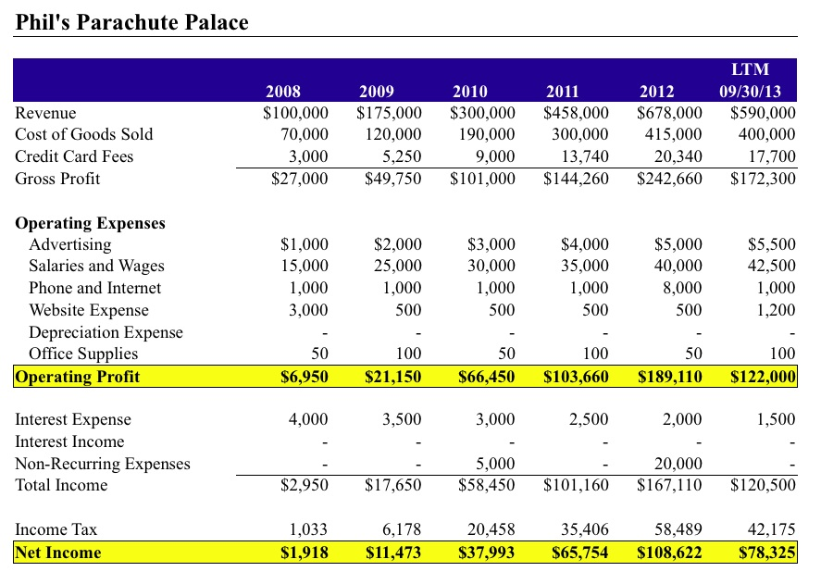
- Income statement: revenues minus expenses over a given time period
- operating income/profit = EBIT
- net income/# of shares = earnings per share
  - market cap / shares outstanding = price per share
  - price to earnings ratio
- revenue only recorded when actually received/sale completed
  - inventory does not effect IS
- Net income indicated whether a company experienced profit or loss

Balance Sheet
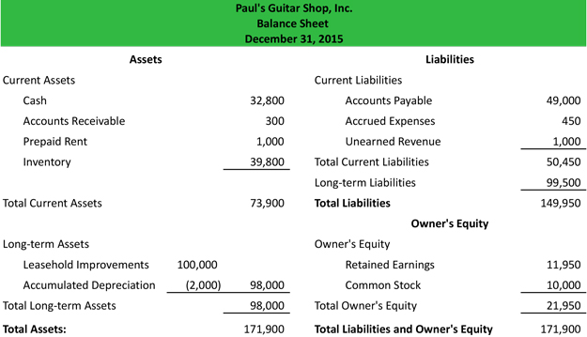

- Retained earnings is a statement that explains what the company has done with its net income for the year
- Value of a company is = value of assets = debt (liabilities) + equity
- They can acquire money either through liabilities and the rest is from shareholders
- Short term assets are ones that are anticipated to be converted to cash within one year
- Accrued compensation is a short term liability because you owe a service
- Balance sheet: snapshot of how the company is doing given its assets minus its liabilities with the difference being shareholders equity

Cash Flow Statement year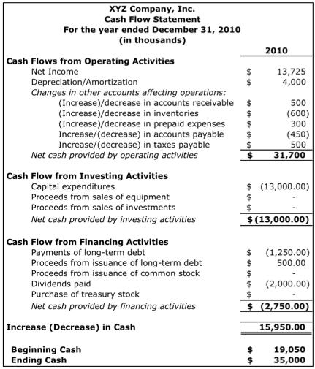
- Cash flow statement is also over a time period and shows the amount of cash on hand given cash flow from operations, finances, and investment
- Operating activities: cash transactions involved in every day business
- Investing activities: cash-assets from balance sheet (not including depreciation or write downs)
- Financing activities: payments or receivables to or from debt or equity holders

